**Family Music for Toddlers**

**What Do You Hear?**

Help your child discover the love of music!

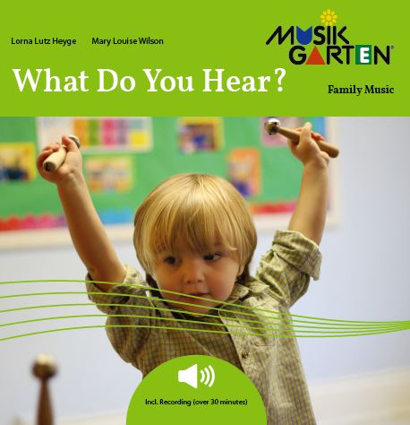What do you hear? Whose voice is that? Is it high or how, is it fast or slow? The ability to really listen, to discriminate sounds and focus attention, is fundamental to learning, and music class is the perfect environment.

Activities Include:

* Sing about trains and listen to the sound of a steam engine
* Go for a fun ride on the Merry-Go-Round
* Play simple instruments to *Sing-a-Ling-a-Ling*
* Rock to the lullaby *Ho, Ho, Watanay*
* Make music with your friends and family

Family Activities and Materials:

* Musikgarten recording that will keep your attention. You’ll hear fast-tempo music as well as calming, slower relaxing music
* 24 page children’s picture/activity book

Your studio registration information, schedule, cost

Contact info

Phone number

Website address