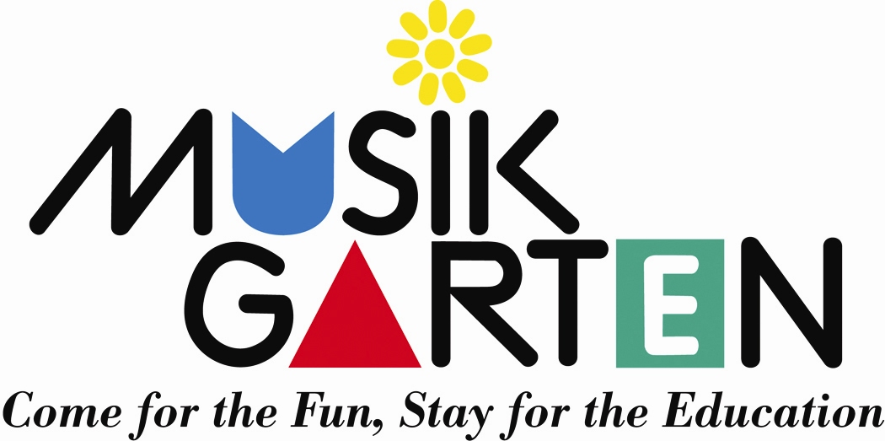
All Together Now

Mixed Ages: birth to age 4

For families with more than one child

Nursery Rhymes + Music =

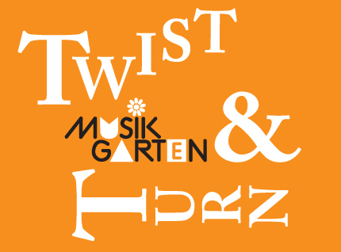
Fun for Siblings and Parents

Musikgarten has captured the magic of nursery Rhymes in its new program called Twist and Turn.

○The delightful language and the movement response it evokes, speak to the most active children as they explore walking, jumping, twisting, and turning…

“Oliver Twist, you can’t do this”
○The rhyming words and playful rhythms help children to quickly catch on to the verses, allowing them to participate fully…

“Dr. Foster went to Gloucester”
○The tales told by the nursery rhymes and song material encourage the older children as they are developing language skills and challenge them to use their imaginations in new ways. The rhymes and songs are just as appealing to the younger children in the room, whether it is a toddler enjoying the movement, or instrumental play or the infant who is simply enjoying the sound of the music and the rhythm of the words as s/he bonds with his/her mother.

Families will receive
• A comprehensive family packet with a lively CD
• A companion book
• A pair of “grooved” rhythm sticks

Twist and Turn
9:30 – 10:15 each Wednesday for 5 weeks, June 25 – July 23, 2008
OR
11:00 – 11:45 each Wednesday for 5 weeks, June 25 – July 23, 2008
$xx.xx for families with 1 or 2 children; $20 for each additional sibling

Your Musikgarten Studio
www.yourstudio.com
800-555-1212

