**Family Music for Toddlers**

**Playing Outdoors**

Help your child discover the love of music!

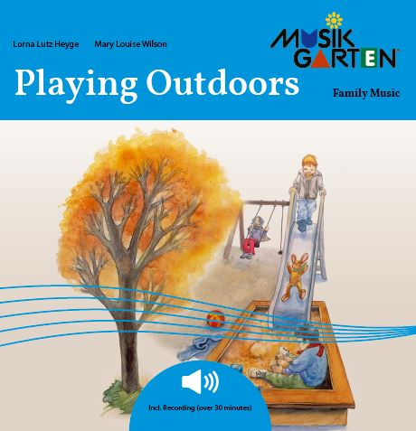Playing outdoors is such fun for children, and so very important, especially in our day. There are many sounds to hear, wonderful places to play and work, and room to move, move, move! Go outside with your child!

Activities Include:

* Sing about ducks and birds
* March around to *The Grand Old Duke of York*
* Go fishing
* Listen to the Robin or Owl sing
* Make music with your friends and family

Family Activities and Materials:

* Musikgarten recording that will keep your attention. You’ll hear fast-tempo music as well as calming, slower relaxing music
* 24 page children’s picture/activity book

Your studio registration information, schedule, cost

Contact info

Phone number

Website address