Personalize* and Distribute this Flyer in Your Community:

Musikgarten Adults
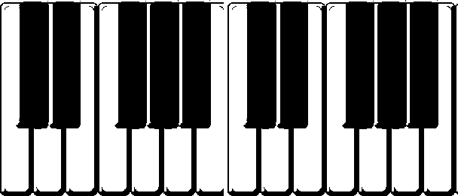

Enjoying the Piano Together
A Recreational Music Making Program

Come experience the joy of learning to play the piano!

Join others in a fun and relaxing group class.

Discover the value of making music together!

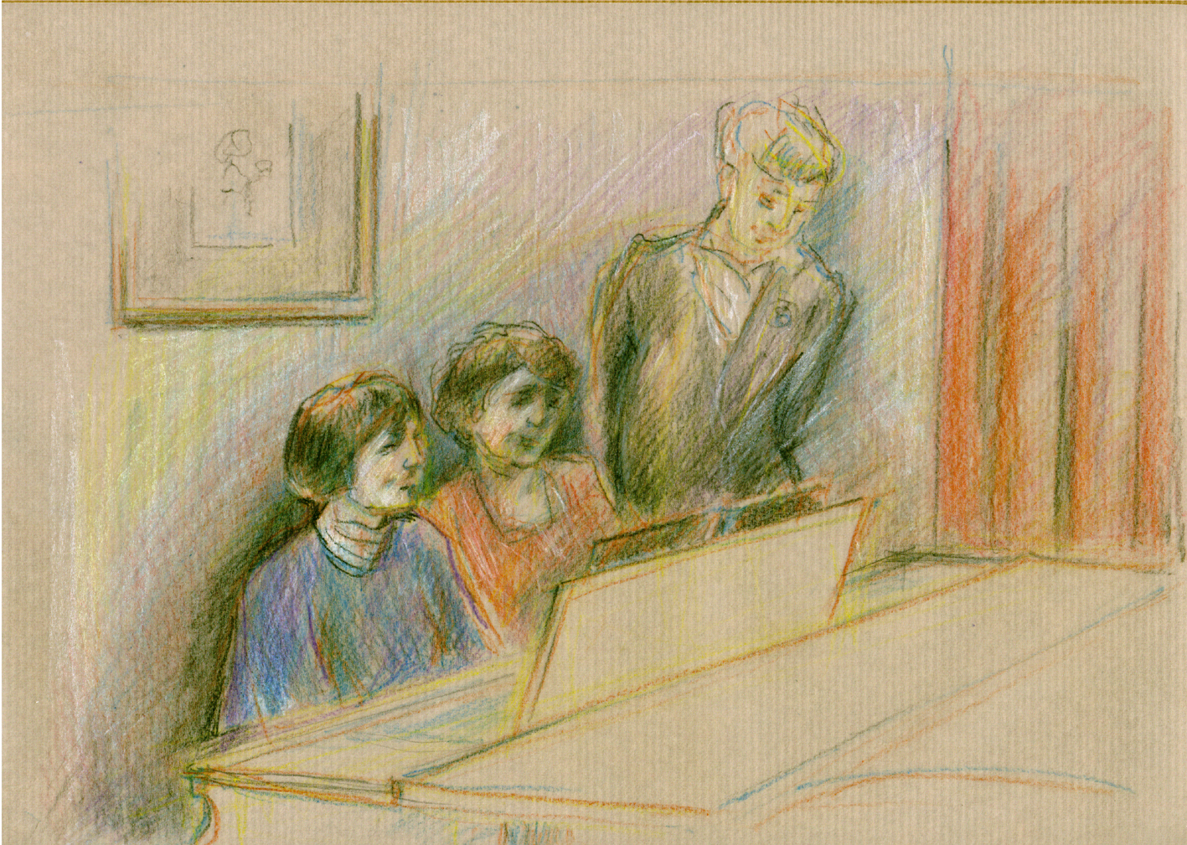
~Comfortable learning environment

~Social interaction

~No prior musical experience needed –
just enthusiasm and a love of music

~Experience the joy of making music with
others, with no performance pressure.

Recent scientific studies have established the connection
between active music-making and improved physical wellness.

8-week course for adults
(place and time)
(starting date)
$ - includes the piano book and accompanying CD

Instructor:

For more information or to register, call or email:

*This flyer will be sent electronically to enable teachers to personalize it.

