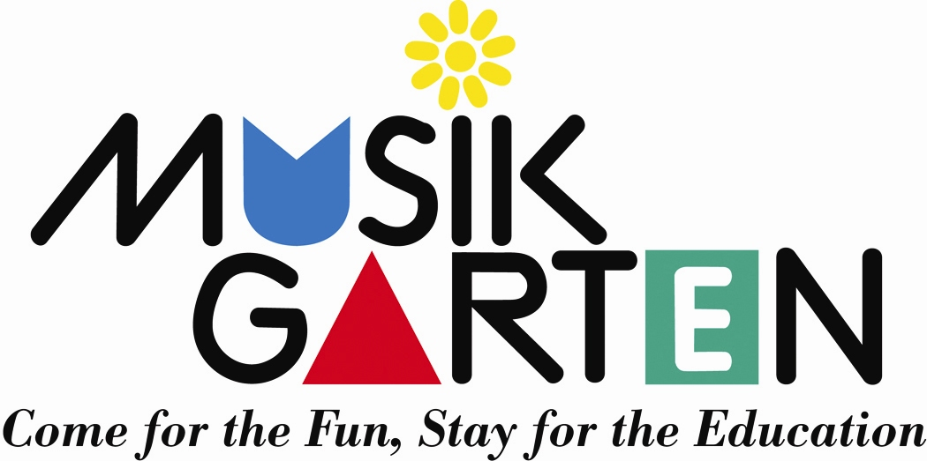

Camping at the Seashore
Summer Music for Children Ages 4-7
Explore a Whole New World of Story and Song at the Seashore!
“Camping at the Seashore was our son’s favorite summer activity. I’ve never seen him so focused; the music brought the seashore to life for him!”

Explore the magical place where the ocean meets the land
- Encounter creatures of the sea: whale, pelicans, and turtles
○ How do these sea animals move? Can I do that?
○ What sounds do they make?
- Study shells and make paper boats.
- Dance and leap like the waves!

Activities Include
- Singing and dancing, movement activities, and playing instruments
- Storytime about the magical seashore
- Making instruments to take home
- Listening to the sounds of the seashore and to the viola, harp and flute
- Simple nature crafts and art activities
- Family Time with siblings to end each day

Family Activities and Materials
- Outstanding Musikgarten CD
- Full-color 11x17” sea picture for each child, with cut-out animals
to move around the environment
- Parent Activity Book, with immersion activities to help each family

“fall in love” with the sea

$xxx for 5-day camp; 9 – 11:30 am; materials and snack included
Month day – Month Day

Your Musikgarten Studio www.yourstudio.com 800-555-1212

